

Name: Niladri Banik
ID Number: 2418726049
Subject: Python Programming Lab (MCAN-191)
Roll No: 18771024011
Stream: MCA
Year: 2024-2025
Semester: 1st Sem

Write a program in Python to show concatenation of First name, Middle name and Last name. At the end print a message welcoming that person.

f_name = input("Enter your First Name: ")

m_name = input("Enter your Middle Name: ")

l_name = input("Enter your Last Name: ")

full_name = f_name + " " + m_name + " " + l_name

print("Welcome, " + full_name)

Output:
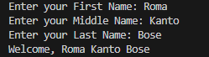

Write a program in Python to show the use of case related string methods. (upper, lower, capitalise, title, swapcase, casefold)

n = input("Enter a string: ")

print("Original String:", n)

print("Uppercase:", n.upper())

print("Lowercase:", n.lower())

print("Capitalized:", n.capitalize())

print("Title Case:", n.title())

print("Swap Case:", n.swapcase())

print("Casefold:", n.casefold())

Output:

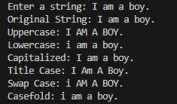

Write a program in Python to count number of words in a string. (Assume words are separated by one or more spaces).

t = input("Enter a string: ")

w = t.split()

count = len(w)

print("Number of words in the given string:", count)

Output:

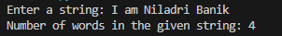

Write a program in Python to count number of vowels, consonants, digits and punctuation marks in a string.

import string

text = input("Enter a string: ")

v_count = 0

c_count = 0

d_count = 0

p_count = 0

vowels = "aeiouAEIOU"

punctuation = string.punctuation

for char in text:

if char.isdigit():

d_count += 1

elif char in vowels:

v_count += 1

elif char.isalpha():

c_count += 1

elif char in punctuation:

p_count += 1

print("\nNumber of vowels:", v_count)

print("Number of consonants:", c_count)

print("Number of digits:", d_count)

print("Number of punctuation marks:", p_count)

Output:

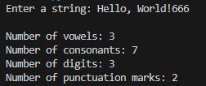

Write a program in Python to check whether a string is a Palindrome or not.

t = input("Enter a string: ")

p_text = t.lower()

if p_text == p_text[::-1]:

print(t,"is a Palindrome.")

else:

print(t,"is NOT a Palindrome.")

Output:

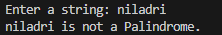
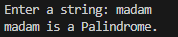

Write a program in Python to remove extra spaces between words in a string.

t= input("Enter a string with extra spaces: ")

cleaned_text = " ".join(t.split())

print("String after removing extra spaces:")

print(cleaned_text)

Output:

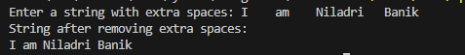

Write a program in Python to convert each character (only alphabetical characters) of a string into the next letter.

n = input("Enter a string: ")

r = ""

for char in n:

if char.isalpha():

if char == 'z':

r += 'a'

elif char == 'Z':

r += 'A'

else:

r += chr(ord(char) + 1)

else:

r += char

print("String after converting each alphabetical character to the next letter:")

print(r)

Output:

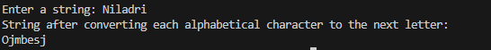

Write a program in Python to find the full abbreviation of a string. (e.g. Techno International New Town gets converted to T. I. N. T.)

text = input("Enter a string: ")

words = text.split()

abbreviation = ""

for word in words:

abbreviation += word[0].upper() + ". "

abbreviation = abbreviation.strip()

print("\nFull abbreviation of the string:")

print(abbreviation)

Output:

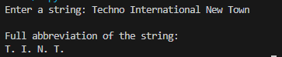

Write a program in Python to find all the words that are ended with the pattern “tion” in a string.

t = input("Enter a string: ")

words = t.split()

m_words = [word for word in words if word.endswith("tion")]

print("Words ending with 'tion':")

if m_words:

print(", ".join(m_words))

else:

print("No words ending with 'tion' found.")

Output:

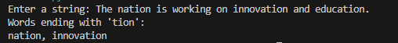

Write a program in Python to check whether a string contains the words ‘BCA” or ‘MCA’.

t = input("Enter a string: ")

if 'BCA' in t or 'MCA' in t:

print("The string contains 'BCA' or 'MCA'.")

else:

print("The string does NOT contain 'BCA' or 'MCA'.")

Output:

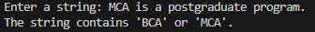

Write a program in Python to show the use of append( ), inset( ) and extend( ).

list = [1, 2, 3]

list.append(4)

print("After append(4):", list)

list.insert(2, 99)

print("After insert(2, 99):", list)

list.extend([5, 6, 7])

print("After extend([5, 6, 7]):", list)

Output:

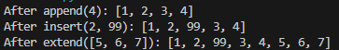

Write a program in Python to show the use of del, remove( ), pop( ) and clear( ).

list = [10, 20, 30, 40, 50]

del list[2]

print("After del my_list[2]:", list)

list.remove(40)

print("After remove(40):", list)

removed_element = list.pop(1)

print("After pop(1):", list)

print("Element removed using pop:", removed_element)

list.clear()

print("After clear():", list)

Output:

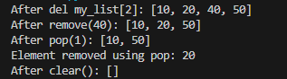

Write a program in Python to show the search, updation, concatenation operation of list.

list1 = [10, 20, 30, 40, 50]

list2 = [60, 70, 80]

search = 30

if search in list1:

print(f"{search} found in list1 at index {list1.index(search)}")

else:

print(f"{search} not found in list1")

print("Before updation:", list1)

list1[2] = 99

print("After updating the element at index 2:", list1)

concatenated_list = list1 + list2

print("After concatenation of list1 and list2:", concatenated_list)

Output:

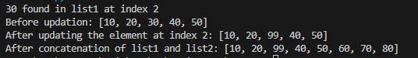

Write a program in Python to access individual members when iterate in a nested tuple.

tuple = ((1, 2, 3), (4, 5, 6), (7, 8, 9))

for in_tuple in tuple:

print("Inner Tuple:", in_tuple)

for item in in_tuple:

print("Item:", item)

Output:

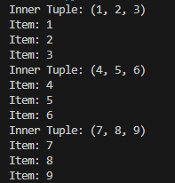

Write a program in Python to remove elements from a set.

my_set = {10, 20, 30, 40, 50}

print("Original set:", my_set)

my_set.remove(30)

print("After remove(30):", my_set)

my_set.discard(50)

print("After discard(50):", my_set)

Output:

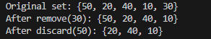

Write a program in Python to show how to access dictionary elements.

dict = {

"name": "Niladri",

"age": 25,

"city": "Lake Town",

"job": "Doctor"

}

print("Accessing values using keys:")

print("Name:", dict["name"])

print("Age:", dict["age"])

print("City:", dict["city"])

print("Job:", dict["job"])

print("\nAccessing values using get():")

print("Name:", dict.get("name"))

print("Age:", dict.get("age"))

print("\nAccessing a non-existing key using get():")

print("Country:", dict.get("country", "Not Found"))

print("\nAccessing all keys and values:")

for key, value in dict.items():

print(key, ":", value)

Output:

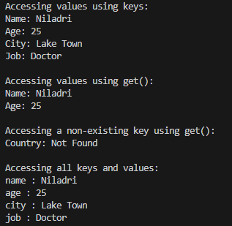

Write a program in Python to show how an element can be added and modified in a dictionary.

dict = {

"name": "Nil",

"age": 25,

"city": "Lake Town"

}

print("Original Dictionary:", dict)

dict["job"] = "Engineer"

print("\nAfter adding a new key 'job':", dict)

dict["age"] = 26

print("\nAfter modifying the value of 'age':", dict)

dict.update({"country": "India"})

print("\nAfter using update() to add 'country':", dict)

dict.update({"city": "Lake Town", "job": "Manager"})

print("\nAfter using update() to modify 'city' and 'job':", dict)

Output:

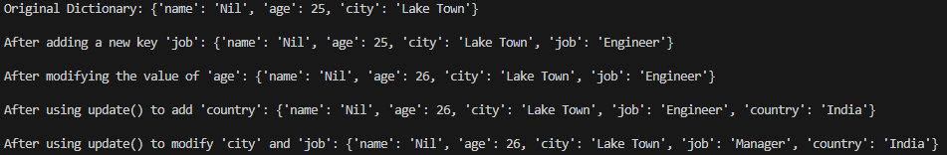

Write a program in Python to show deletion operation in a dictionary.

dict = {

"name": "Nil",

"age": 25,

"city": "Kolkata",

"job": "Doctor"

}

print("Original Dictionary:", dict)

del dict["city"]

print("\nAfter using del to remove 'city':", dict)

removed_item = dict.pop("age")

print("\nAfter using pop() to remove 'age':", dict)

print("Removed item using pop:",removed_item)

removed_item = dict.popitem()

print("\nAfter using popitem() to remove an arbitrary item:", dict)

print("Removed item using popitem:",removed_item)

Output:

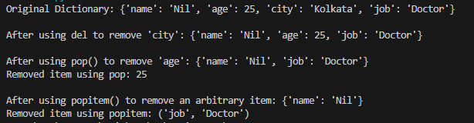

Write a program in Python to access nested dictionary using nested loop.

dict = {

"person1": {"name": "Nil", "age": 30, "city": "Kolkata"},

"person2": {"name": "Nimo", "age": 20, "city": "Lake Town"},

"person3": {"name": "Ram", "age": 39, "city": "Barasat"}

}

for person, details in dict.items():

print(f"\nDetails of {person}:")

for key, value in details.items():

print(f"{key}: {value}")

Output:

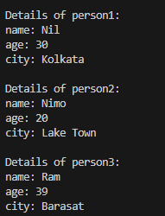

Write a program in Python to find the factorial of a number using recursive function.

def factorial(n):

if n == 0 or n == 1:

return 1

else:

return n * factorial(n - 1)

n = int(input("Enter a number to find its factorial: "))

if n < 0:

print("Factorial is not defined for negative numbers.")

else:

result = factorial(n)

print("The factorial is" ,result)

Output:

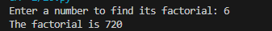

Write a lambda function to find the maximum between two numbers.

max = lambda a, b: a if a > b else b

num1 = float(input("Enter the first number: "))

num2 = float(input("Enter the second number: "))

print("The maximum between", num1, "and", num2, "is:", max(num1, num2))

Output:

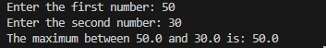

Write a recursive function to print the binary equivalent of a given decimal number.

def decimal_to_binary(n):

if n == 0:

return ''

else:

return decimal_to_binary(n // 2) + str(n % 2)

n = int(input("Enter a decimal number to convert to binary: "))

if n < 0:

print("Binary representation is not defined for negative numbers.")

elif n == 0:

print("The binary equivalent of 0 is 0.")

else:

binary = decimal_to_binary(n)

print("The binary equivalent is ",binary)

Output:

Write a program in Python to draw a line plot.

import matplotlib.pyplot as plt

x = [1, 2, 3, 4, 5]

y = [2, 4, 6, 8, 10]

plt.plot(x, y, label='Line', color='blue', marker='o')

plt.title('Simple Line Plot')

plt.xlabel('X-axis')

plt.ylabel('Y-axis')

plt.legend()

plt.show()

Output:

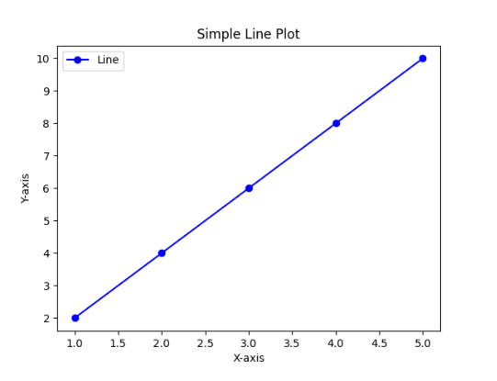

Write a program in Python to draw a histogram.

import matplotlib.pyplot as plt

data = [12, 15, 12, 10, 9, 13, 16, 14, 15, 14, 13, 12, 11, 12, 14]

plt.hist(data, bins=5, color='green', edgecolor='black')

plt.title('Histogram Example')

plt.xlabel('Value Range')

plt.ylabel('Frequency')

plt.show()

Output:

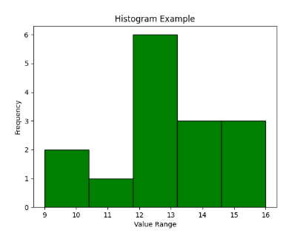

Write a program in Python to draw a pie chart.

import matplotlib.pyplot as plt

labels = ['Python', 'Java', 'JavaScript', 'C++', 'Ruby']

sizes = [40, 25, 15, 10, 10]

colors = ['#ff9999', '#0453', '#99ff99', '#ffbc99', '#c2c2f0']

plt.pie(sizes, labels=labels, colors=colors, autopct='%1.1f%%', startangle=140)

plt.title('Programming Language Popularity')

plt.show()

Output:

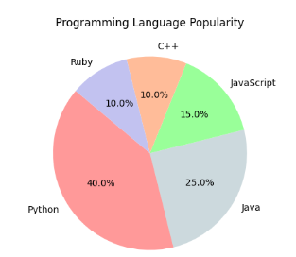

Write a program in Python to draw a horizontal bar plot.

import matplotlib.pyplot as plt

languages = ['Python', 'Java', 'JavaScript', 'C++', 'Ruby']

popularity = [40, 25, 15, 10, 10]

plt.barh(languages, popularity, color='skyblue')

plt.title('Programming Language Popularity (Horizontal Bar Plot)')

plt.xlabel('Popularity (%)')

plt.ylabel('Programming Languages')

plt.show()

Output:

